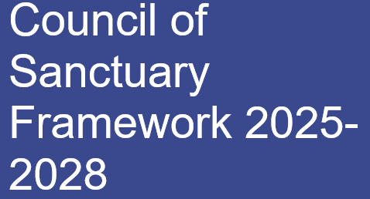

Table of Contents

Foreword by Councillor Linda Smith2

Introduction and Background3

Our Progress – Key Highlights4

Key Challenges5

Partnerships and Governance7

Taking Action8

Sanctuary Data14

Key Terms16

# **Foreword by Councillor Linda Smith**

Oxford is a global City which has a proud history of migration adding a rich diversity to the City and I am proud that Oxford has been a *City of Sanctuary* for various groups over many years. There is a sense of solidarity and community, and the Council works tirelessly to create a thriving community which is inclusive and welcoming.

Since the first Council motion in 2019 where Councillors pledged support to make Oxford a *City of Sanctuary,* the Council has been on a journey to become an accredited Local Authority of Sanctuary. This has culminated in this framework and action plan which sets out the Council’s plan for the next 3 years.

Our goal is to build on the Council's strengths while proactively identifying areas of need and addressing any gaps with effective solutions alongside our partners. The Council is fortunate to receive support and work in partnership with statutory and non-statutory partners from across the County via the Oxfordshire Migration Partnership.   
   
A key aim of the Thriving Communities Strategy is the ethos of ‘doing with, not to’ residents. This framework builds on this philosophy, aiming to develop solutions alongside people with lived experience of seeking sanctuary, statutory services, voluntary and community partners as well as a range of Council services. We have identified the actions laid out in the action plan, across six priority areas. The priorities reflect both key areas of need and opportunities to empower people seeking sanctuary in line with our local strengths and existing strategies.

Unfortunately, in recent times, global conflict, and instability in places like Syria, Afghanistan and Ukraine has led the Council to redouble our efforts to provide an inclusive and welcoming environment to people seeking a safe place to call home. As the need has increased, so have issues such as central government asylum processing backlogs, and the block booking of budget hotels by the Home Office to provide basic accommodation for asylum seekers.

The Council has consistently supported programmes to support vulnerable groups in Oxford including refugees who have been resettled, ensuring that we play our part to support households in need. Whilst there is much more to do, I hope you will see from reading through this framework that there are many stories of success.

Cllr Linda Smith

Cabinet member for Housing and Communities

# **Introduction and background**

This framework document has been developed through engagement with residents and key stakeholders, drawing on real-life experiences and learning from commissioned research. Our aim is to shape a comprehensive plan that enables Oxford City Council to work with partners to improve the outcomes for local people seeking sanctuary and the wider community. The document is organised into key sections, offering insights into the Council’s efforts to support this area of work and the journey the Council has been on.

Many people come to Oxford in search of sanctuary, support, or a warm welcome. To ensure we are inclusive of the broad range of legal statuses, living circumstances and experience of migration held by these residents we choose to use the term ‘people seeking sanctuary’ throughout this framework. Where certain conditions, criteria or experiences only apply to subsections of this population we include specific reference to this in the pages below.

Our vision for Oxford City Council as a local authority of sanctuary is to create a welcoming and safe environment where those seeking sanctuary feel supported, accepted, and embraced as part of the broader community. A city where all residents can thrive, contribute, and actively participate in the community, helping to shape the future and enrich the life of Oxford for all.



Oxford has long been a destination for international migrants, be it for work or study, bringing valuable skills and knowledge and making the city diverse and global. Two world reputed universities, globally renowned science parks, sizeable teaching and practicing hospital systems, and large technology and automobile industries provide opportunities for economic and social mobility for many far and wide.

Oxford has also been a place where people have settled seeking safety and security. The Council has consistently supported refugee resettlement and integration against a backdrop of growing need both locally and internationally. The Council passed the first motion to be a *City of Sanctuary* in 2019, followed up in 2022 when the Council passed a further motion to consider the support on offer to people seeking sanctuary considering global conflicts.

Windows painting created by the residents of local asylum hotels, hosted by the Museum of Oxford and displayed at Oxford Town Hall for Refugee Week, 2024

The Council committed to becoming a local authority of sanctuary in 2023 and develop an action plan to set out how the Council will work with people seeking sanctuary over the next three years. This is set out in this framework document alongside key areas of progress, challenge, as well as quotes from community voices detailing their experience of sanctuary in Oxford.

# **Our Progress – Key Highlights**

The Council has made notable progress and reached significant milestones on its journey to becoming a local authority of sanctuary in recent years, achievements made possible through the continued support of the partnerships as outlined below:

* **The Oxfordshire Migration Partnership** was established in 2022 in response to the Ukraine crisis to coordinate the Homes for Ukraine (HfU) scheme across local stakeholders. Oxford City Council collaborated with Oxfordshire County Council, along with district authorities and other partners. Key successes include pooling resources to expand housing options, preventing homelessness and commissioning projects for people seeking sanctuary and local residents.
* **Since 2022,** around 200 resettled individuals have undertaken ESOL tuition as part of the resettlement programmes and many more have been signposted to local mainstream community provision.
* **In 2022,** the City Council, in partnership with NHS services, launched the Community Health Champions initiative to support COVID-19 vaccination rollout for vulnerable communities. Ten people seeking sanctuary have been trained as Community Health Champions to improve healthcare access and promote wellbeing.
* **In 2016 Refugee Resource** was commissioned to provide additional mental health support for resettlement families, offering specialised counselling and therapeutic mentoring. This vital service has been continuously maintained to ensure ongoing support for those in need.
* **In 2017 The Museum of Oxford** hosted the Journeys to Oxford exhibition telling migrants’ tale of how they got here. This included the testimonies of about 115 Oxford City residents of 45 different nationalities, from Poland to Pakistan and China to the Caribbean.
* **In 2018 the Council secured funding through the Controlled Migration Fund which led to number of projects including co**mmissioning local charities to establish local mentoring and volunteering program for people seeking sanctuary, work based-ESOL classes, human trafficking and modern slavery and a project supporting rough sleepers.

Community Voice:

*“For me Oxford is a place of safety and empowerment”* says Lubna, a mother from Iraq who came to Oxford in 2022 with her children to join her husband who was already in the UK. Since then, alongside bringing up her family, she has volunteered tirelessly in the community and become a community artist.

* The **Schools Advocacy Programme**, run by Asylum Welcome and funded by Oxford City Council since 2020, helps families and schools by improving engagement, access to educational services, and understanding of the UK school system. So far, 105 children from 35 families across 25 schools have benefited, with schools describing the service as “invaluable” and “pivotal.”
* In 2023, Oxford City Council commissioned Aspire Oxford, Asylum Welcome, Refugee Resource and EMBS college to run the **Refugee Employment Support Programme (RESP).**Since then, 24 refugees have been supported and 51 employers engaged.
* In 2024 the Council funded the **Health Access Project**, run by Asylum Welcome, which has supported people seeking sanctuary with health and dental services and has developed a multilingual healthcare hub.

Community Voice:

Kate has hosted and supported 25 sanctuary seekers in her home since 2015 under a charity run hosting scheme. Kate said *“Oxford is the most welcoming place for people seeking sanctuary, and we are lucky to have very rich and wide cultures. Also, I feel very fortunate to be hosting those people in need. I have learnt a lot from them, and I admire their resilience”.*

# **Key Challenges**

Oxford has a resilient economy, world renowned higher education, science and research sector. However, there are high levels of inequality and Oxford has several areas of high deprivation where most local people seeking sanctuary reside. People seeking sanctuary face many barriers and challenges as they endeavour to rebuild their lives and make a new home. These challenges are exacerbated by global or national policies or pressures and are summarised below:

* **Global conflict / increased migration** [United Nations statistics](https://www.unhcr.org/uk/about-unhcr/who-we-are/figures-glance) estimate over 120 million people were forcible displaced by 2024. The majority are displaced internally or flee to neighbouring countries. A small percentage make their way to the UK. People seeking sanctuary arriving in Oxford are fleeing conflicts and persecution as well as environmental disasters, driven by climate change, alongside economic challenges, worsened by the COVID-19 pandemic.
* **National policy challenges** In 2022, Oxford became an expanded asylum dispersal area, leading to the use of temporary housing for asylum seekers. Government legislation has sought to act as a deterrent for people arriving through irregular routes and increased the requirements for an individual to claim asylum. There is variation in how the UK’s responds to different crises, which has led to the creation of bespoke visa and resettlement schemes affecting rights and entitlements.
* **Housing demand & supply/homelessness** Oxford is one of the least affordable UK cities, with high rents and a shortage of affordable housing. People seeking sanctuary, with limited financial resources, struggle to secure housing due to long social housing waitlists, lack of credit history, and private rental market access issues. After receiving refugee status, they must leave asylum support accommodation within 28 days, often risking homelessness.
* **Cost of Living crisis** People seeking sanctuary in Oxford are deeply affected by the cost-of-living crisis, with rising energy costs pushing many into "fuel poverty." Limited income forces choices between essentials like heating and food. Language barriers and unrecognised qualifications make it hard to find stable jobs, while competition for low-wage work increases hardship. Children face difficulties as families struggle with school expenses whilst local charities struggle to meet the growing need.
* **Health inequalities** People seeking sanctuary face unique health challenges and barriers to healthcare due to lack of documentation, language difficulties, and confusion about eligibility. This limits access to primary care, mental health services, and preventive healthcare. Language barriers can lead to miscommunication, misdiagnoses, and inadequate treatment, especially for mental health needs. Poor housing and food insecurity contribute to health problems and women and children, particularly, face additional challenges.
* **No Recourse to Public Funds (NRPF) / vulnerable migrants** People with No Recourse to Public Funds (NRPF) in Oxford face severe challenges due to high living costs and limited support. Unable to access public housing or benefits, many risk homelessness or live in unsafe conditions, relying on overstretched charities. Employment can be restricted due to immigration status which can lead to exploitation in low-paying jobs without labour protections. Financial hardship is common, often leading to debt. Children in NRPF families also face barriers to accessing school meals and educational resources, affecting their well-being

Community Voice:

“*If you hardly speak English and you are a stranger in a foreign culture it’s like being blind and deaf when you want to talk to someone. Before they helped me, I felt powerless and invisible. Now I have a voice, and I can help others like me*. HB from Syria

**Partnerships and Governance**

The Council has set clear objectives outlined in the *Taking Action* section below. However, it remains impacted by broader financial challenges, as constrained local government finance has been impacted by tight central government settlements and rapidly rising costs. It’s clear that the Council is not able to deliver on all its aspirations without working in partnership. This is very much the model the Council aspires to, as Oxford is fortunate to have a thriving voluntary and community sector and the Council also works in close collaboration with other statutory agencies including local Oxfordshire County Council, District Councils, and other partners such as the NHS via the Oxfordshire Migration Partnership.

Partnership work via the Oxfordshire Migration Partnership has increased the level of inter-agency working and allowed a more co-ordinated response to tackle emerging issues related to migration within Oxfordshire. The Council is keen to work in partnership with other agencies such as Oxfordshire County Council who have passed a Council motion to become an accredited Local Authority of Sanctuary and lead on co-ordination for the Oxfordshire Migration Partnership.

Strong partnerships with different organisations like Asylum Welcome, Refugee Resource, Aspire Oxford and Connection Support and other community groups, have helped Oxford City Council widen our impact and work together on new and innovative projects. The action plan embedded within this framework identifies key actions for the Council, other statutory agencies and the voluntary and community sector. It has been developed in partnership and reflects the understanding that better outcomes will be achieved if we work together to pool resources, knowledge, and expertise.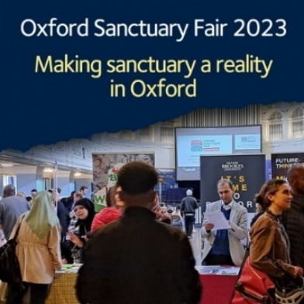

Based on close collaborations with lived experience organisations the Council has been actively involved in providing more inclusive and holistic support for people seeking sanctuary. We are proud to celebrate refugee experiences through Refugee Week celebrations and the annual Sanctuary Fair. So, while we aim to do better with regards to our statutory duty, our overall approach and plan is to go beyond business as usual.

The Council will continue to show leadership by using grant funding to invest in staffing and new projects to support people seeking sanctuary. Alongside the Council’s operational role, Officers will also advocate for a fair funding settlement from central government and seek to influence the direction of national policy.

Accountability for this action plan is important and Officers will be reporting back to Oxford City Council Cabinet on yearly progress. Progress will be tracked routinely through the Council’s internal governance structures, reporting to the Communities Change Board monthly. Officers have developed internal and external sanctuary partnership groups who will also be meeting periodically to jointly assess progress and identify new key actions.

# **Taking Action**

The Council has explored the views of people seeking sanctuary and the local community and what the Council can do to improve their experience.  We began with the Thriving Communities Strategy Consultation where the voices of many local people sanctuary were recorded.  The following year in October 2023, we commissioned Asylum Welcome to deliver a needs assessment for our Council of Sanctuary project and more recently carried out community engagement work, meeting local residents.

The needs assessment and our research explored the views of people seeking sanctuary including their experiences, and opinions on Council services. Many positives were highlighted including the safety, beauty and reputation of the city, alongside the availability of cultural activities, outdoor space and friendly communities.

However, a number of barriers emerged, often linked to an individual’s immigration status and support needs, but they were connected by the common thread of trying to settle and rebuild lives in a new environment and place with different cultural, legal and societal norms.

The report grouped the key areas of challenge into four key themes: transport; health and wellbeing; education and employment; and accommodation.  As the Council is not a unitary authority, some issues raised in the research fall within the remit of other partners we will work with partners to address these.

Where work cuts across other organisations provision, we have indicated in the action plan how we will work together to action the recommendations in the ethos of the partnership model. We have identified the actions across 6 priority areas, to be reviewed regularly with partners. The priorities reflect both key areas of need and opportunities to empower people seeking sanctuary in line with our local strengths and existing strategies and are listed below:

**Wellbeing, Education & Employment** **Housing and Homelessness**

**Building Communities & Amplifying Voices** **Shaping Services**

**Supporting Integration** **Working in Partnership & Innovating**

**1. Wellbeing, Education and Employment**

|  |  |  |  |
| --- | --- | --- | --- |
| **What are we going to do?** | **Service** | **By end of year**  **1- 2025**  **2- 2026**  **3- 2027** | |
| * 1. Educate and empower Council teams and local businesses about opportunities to employ people seeking sanctuary and how to offer placements and apprenticeships, including through myth-busting on migrant entitlements with businesses as well as job brokers. | | Regeneration and Economy | Year 1 |
| * 1. Evaluate the Refugee Employment Support Programme (RESP), its findings and respond to the recommendations. Explore opportunities for further work around employment, business support and social enterprise. | | Housing Services | Year 1 |
| * 1. Work with the anti-slavery coordinator and local modern slavery network to promote understanding around rights and safeguarding risks faced by people seeking sanctuary locally. | | Community Safety | Year 2 |
| * 1. Work with key partners to develop and extend the existing [schools advocacy project](https://www.asylum-welcome.org/services/schools-advocacy-project/), subject to project viability. | | Housing Services | Year 1 |
| * 1. Improve access to wellbeing and leisure facilities for local people seeking sanctuary to improve health outcomes and reduce health inequalities. | | Community Services | Year 2 |
| * 1. Work with partners including Refugee Resource to improve therapeutic outcomes for people seeking sanctuary. | | Housing Services | Year 2 |

**2. Housing and Homelessness**

|  |  |  |
| --- | --- | --- |
| **What are we going to do?** | **Service** | **By end of year**  **1- 2025**  **2- 2026**  **3- 2027** |
| * 1. Expand education and support for local people seeking sanctuary to help them navigate the housing system, especially for those experiencing homelessness, those at risk of homelessness, and those with limited experience of independent living (including UASC) in line with the Housing, Homelessness and Rough Sleeping Strategy. | Housing Services | Year 2 |
| * 1. Provide training as appropriate for housing colleagues on how to support people seeking sanctuary, e.g. residents with varying immigration status including victims of domestic abuse with no recourse to public funds. | Housing Services | Year 2 |
| * 1. Develop further training on working with refugees (cross cultural communications and trauma informed practice) and offer it to colleagues. | Housing services | Year 2 |
| * 1. Increase engagement and support for landlords who wish to house people seeking sanctuary, including information and communication on the Council’s private rented housing access schemes. | Housing Services | Year 2 |
| * 1. Provide appropriate support to sustain tenancies as part of the Council’s approach to homelessness prevention and in line with the Housing, Homelessness, and Rough Sleeping Strategy. | Housing Services | Year 1 |
| * 1. Improve monitoring of the number of people seeking sanctuary who are sleeping rough and use intelligence to target support. | Housing Services | Year 1 |

**3. Building Communities and Amplifying Voices**

|  |  |  |
| --- | --- | --- |
| **What are we going to do?** | **Service** | **By end of year**  **1- 2025**  **2- 2026**  **3- 2027** |
| * 1. Empower and support local institutions to become registered places of sanctuary including libraries, surgeries arts, community, colleges, and faith organisations. | Housing Services | Year 3 |
| * 1. Act as a lead Local Authority on joined-up campaigning for migrant rights, share learning and expertise through sanctuary networks at a local, regional, and national level including the City of Sanctuary Local Authority Network. | Housing Services | Year 3 |
| * 1. Continue to convene the Oxford City Council of sanctuary internal and external stakeholders' meetings to meet regularly to facilitate the Thriving Communities vision of “Doing with, not to” and advocate for an ethos and practice of [’Co-production’](https://cityofsanctuary.org/events/co-production-workshop/) | Housing Services | Year 1 |
| * 1. Support refugee partners and community groups to access opportunities in arts, culture, and community activity via the use of our facilities, grants, and external funding. * Collaborate with the local VCS to build capacity and participation of local lived experience groups via funding advice and support. * Develop effective pathways into volunteering and participation via social and cultural activities. | Community Services | Year 2 |
| * 1. Build capacity of local sanctuary seeking community via [Sanctuary Ambassadors](https://ambassadors.cityofsanctuary.org/) programme and access to the [Sanctuary in Politics](https://ambassadors.cityofsanctuary.org/sanctuary-in-politics) course. | Housing Services | Year 3 |
| * 1. Support refugee community groups to access spaces and places where they can come together to enjoy common interests and create new friendships. | Community Services | Year 2 |

**4. Shaping Services**

|  |  |  |
| --- | --- | --- |
| **What are we going to do?** | **Service** | **By end of year**  **1- 2025**  **2- 2026**  **3- 2027** |
| * 1. Develop/co-produce and share a sanctuary framework to support people seeking sanctuary and promote independent living for those staying in the City and beyond. | Housing Services | Year 1 |
| * 1. Review incorporation of sanctuary principles into services when strategies, policies or services are changed. | Corporate Strategy | Year 2 |
| * 1. Develop online resources to be more accessible for people seeking sanctuary including the Council’s web page, the Communities Toolkit and information regarding accessing housing and other support. | Housing, Communities and Customer Services | Year 2 |
| * 1. Create opportunities and space for people seeking sanctuary to have their voices heard and their stories told, so that their experiences can inform how services are delivered in the city. Ensure people seeking sanctuary can feed into Council activity through existing mechanisms. | Housing Services | Year 1 |
| * 1. Promote sanctuary informed practice across local strategic partnerships where Oxford City Council is key stakeholder. | Housing Services | Year 1 |
| * 1. Via the community health champions programme improve advocacy for people seeking sanctuary and access to primary health care for vulnerable and undocumented migrants. | Community Services | Year 1 |

**5. Supporting Integration**

|  |  |  |
| --- | --- | --- |
| **What are we going to do?** | **Service** | **By end of year**  **1- 2025**  **2- 2026**  **3- 2027** |
| * 1. Grow and publicise wider migrant-specific information, advice and guidance for all residents such as a Sanctuary Door initiative (Single Point of Contact), embedding opportunities for people with lived experiences to lead on service support. | Housing Services | Year 1 |
| * 1. Continue to support local people seeking sanctuary who settled under government schemes including UK resettlement scheme (UKRS), Afghan Resettlement schemed (ARAP, ACRS), Asylum Dispersal Scheme and Homes for Ukraine scheme in line with statutory duties, corporate objectives and viability requirements. | Housing Services | Year 1 |
| * 1. Support the Council’s ambition to support the Domestic Abuse Housing Alliance (DAHA) accreditation and feed in from sanctuary seeking groups perspective. | Regulatory Services and Community Safety | Year 3 |
| * 1. Via sanctuary ambassadors programme and the external stakeholders group review availability of legal advice services for people seeking sanctuary. Alongside community partners, explore opportunities to support expansion of provision as well as pathways to access, and to provide residents with information about their rights. | Housing Services | Year 2 |
| * 1. Work alongside the Oxford Food Hub and other local charities to raise awareness of free or low-cost food options for people seeking sanctuary, in relation to accessing food, and engaging in the wider local food system and increasing communication to ensure people seeking sanctuary are aware. | Housing services supported by Communities | Year 2 |
| * 1. Produce a joint calendar of events which promote integration and support sanctuary events such as during Refugee week | Housing services supported by Communities | Year 1 |

**6. Working in Partnership and Innovating**

|  |  |  |
| --- | --- | --- |
| **What are we going to do?** | **Organisation/ Group** | **By end of year**  **1- 2025**  **2- 2026**  **3- 2027** |
| * 1. Support local research bodies to (a) create and develop body of evidence demonstrating the positive impact of people seeking sanctuary locally and (b) analyse the benefits and opportunities they bring. | Council of Sanctuary external stakeholders' group | Year 3 |
| * 1. Support Oxfordshire County Council and other key partners to increase English language provision (ESOL) accessibility to those with different immigration status, ages, childcare provision needs or access needs in a wide range of both statutory and community settings across the City. | Oxfordshire County Council | Year 2 |
| * 1. Support the Getting Oxfordshire Online Digital Inclusion network, to bring together partners to identify digital barriers for refugees and asylum seekers in the City / county and promote greater digital inclusion for this group. | Oxfordshire County Council supported by the CoS external stakeholders’ group. | Year 1 |
| * 1. Collaborate with local partners and individuals seeking sanctuary to develop culturally appropriate and accessible health initiatives, with a strong focus on expanding access to mental health support. Engage with relevant charities and public services to explore and enhance support networks and resources. | Council of Sanctuary external stakeholders' group | Year 3 |
| * 1. Review existing support available to people with No Recourse to Public Funds (NRPF) via the establishment of an NRPF working group with Oxfordshire County Council and local VCS. | Council of Sanctuary external stakeholders' group | Year 1 |
| * 1. Alongside partners, work to ensure asylum seekers have access to low affordable public transport and travel around the city. | Oxfordshire County Council | Year 2 |

# **Sanctuary Data**

The 2021 Census showed that 35% of Oxford's population was born outside the UK, compared to 28% in the 2011 Census. Most of the foreign-born population come to Oxford for work or study. There have been significant changes in the demographic population of Oxford City recently especially since 2022. A combination of wide-ranging changes to national policy and external factors (e.g., the war in Syria and Ukraine, political unrest in Afghanistan and Hong Kong) have facilitated this.

As a Council we have had to respond quickly not only to an increasing number of people seeking sanctuary living locally, but also to understand how the different immigration statuses these individuals hold affect their experiences and their entitlements. We have had to adapt our services accordingly and we have recorded some key sanctuary data for Oxford:

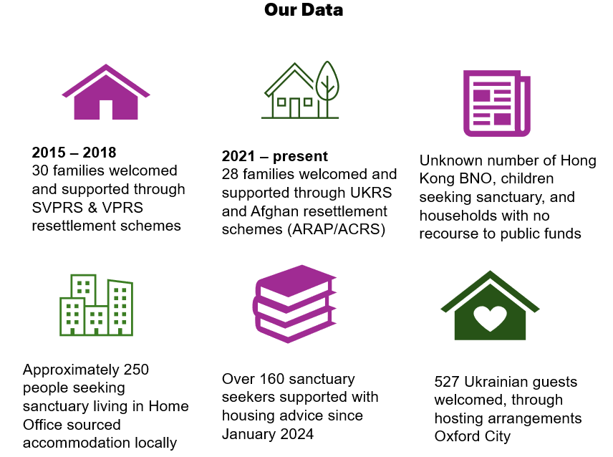

Data on people seeking sanctuary in Oxford can be limited or held by different authorities. People seeking sanctuary are not continuously tracked or recorded in the wider system beyond their initial grant of status, making their needs as trauma-affected, newly arrived individuals often unrecognised and unmet. For those who work with them, gathering reliable information is challenging due to instability in their lives, long asylum processing times, frequent relocations, and homelessness.

Some groups are particularly under-documented, including no recourse to public funds (NRPF) women on spousal visas, students fearing to return to their home countries because of a well-founded fear of persecution, and those trapped in domestic servitude or debt bondage. This lack of data hampers effective support, service provision and requires work with other agencies to understand data on marginalised groups residing in Oxford which we intend on progressing as part of the council’s action plan.

The Council has access to general data sets and the below information was compiled by the council’s **Business Intelligence Unit** for this framework document taken from the Census 2021, Office for National Statistics (ONS).

1. Oxford Resident’s Country of Birth

Source: Census 2021, ONS.

A way of understanding the composition of Oxford’s residents, regarding ethnicity and nationality is the resident’s place of birth. The following graph shows the distribution of countries of birth.

Considering only the 34.92% of people that was not born in the UK and British Overseas (taking aside the 65.04% and 0.04% respectively), the following visual shows the distribution among the rest of the countries where Oxford Residents were born.

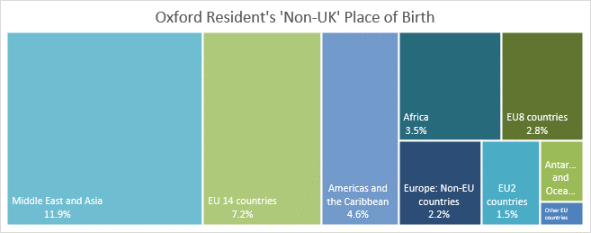

# **Key terms**

|  |  |
| --- | --- |
| **Key term** | **Description** |
| Asylum seeker | In the UK, a person who is seeking asylum or sanctuary is known as an asylum seeker because they have:   * fled their home * arrived in another country, whichever way they can * made themselves known to the authorities * submitted an asylum application * a legal right to stay in the country while waiting for a decision |
| Refugee | Refugees are people who have fled war, violence, conflict or persecution and have crossed an international border to find safety in another country. The 1951 Refugee Convention is a key legal document and defines a refugee as: “someone who is unable or unwilling to return to their country of origin owing to a well-founded fear of being persecuted for reasons of race, religion, nationality, membership of a particular social group, or political opinion.”  In the UK a refugee:   * has proven that they’d be at risk if returned to their home country * has had their claim for asylum accepted by the government * has permission to stay in the UK either long term or indefinitely |
| Migrant | A migrant is a person who moves from one country to another, this could be for several reasons, for example to work, study or to reunite with family. |
| No recourse to public funds | This is a condition for a person that is subject to immigration control, and it means that they are not entitled to most public benefits due to their immigration status, for example a student, someone on a spousal visa or a visa overstayer. |
| Separated or Unaccompanied children | Separated children and young people seeking sanctuary is an alternative to use of the acronym /abbreviation UASCs (Unaccompanied Asylum-Seeking Children) or UAM (Unaccompanied Minors).  Unaccompanied can imply a deliberate decision to send lone children into danger and does not reflect the fact that many lose their families in the chaos of fleeing war and other dangers. In the UK, they are usually looked after by the local authority. |
| Indefinite Leave to Remain | This is an immigration condition that gives a person the right to live indefinitely and is also called 'settlement'. It gives a person the right to live, work and study and apply for benefits. It can also be used to apply for British citizenship. |
| Forced migrant | A term commonly used for a person subject to a migratory movement in which an element of coercion exists, including threats to life and livelihood, whether arising from natural or man-made causes (e.g. movements of refugees and internally displaced persons as well as people displaced by natural or environmental disasters, chemical or nuclear disasters, famine or development projects or those who have been trafficked or enslaved). |
| A Person Seeking Sanctuary | An umbrella term for someone seeking safety irrespective of immigration status. |

